This is a great series of images taken by a customer who transformed a failed Home Improvement Center epoxy floor that the previous home owner applied into an ArmorGarage epoxy floor.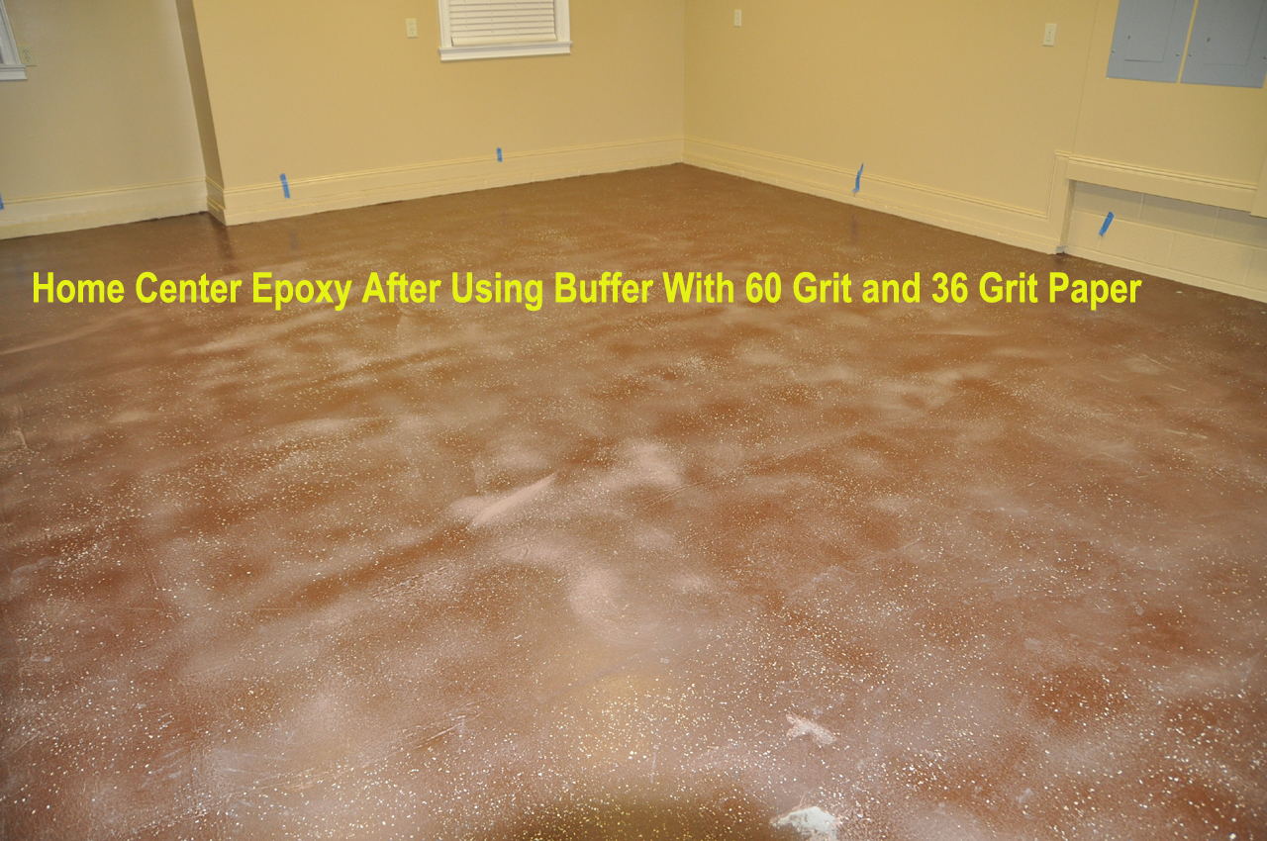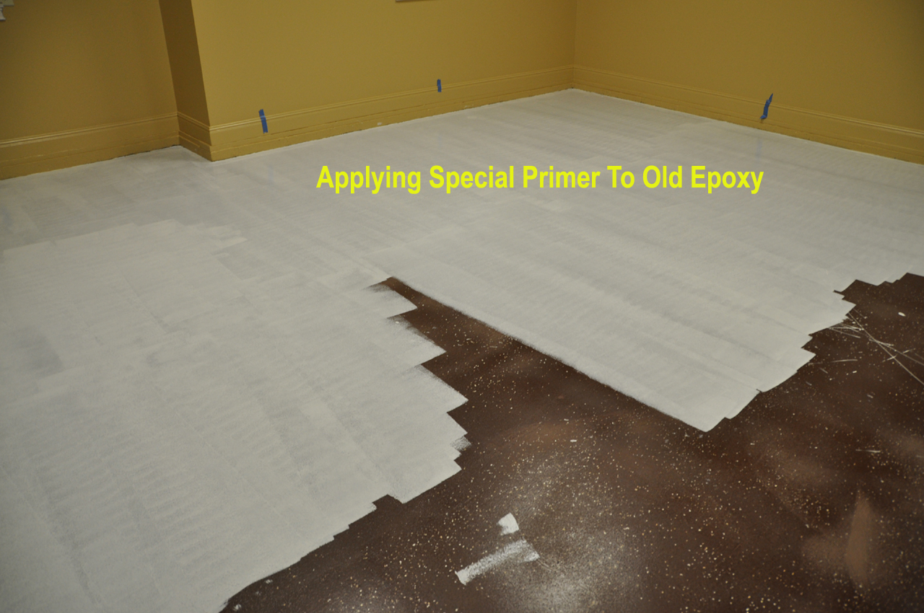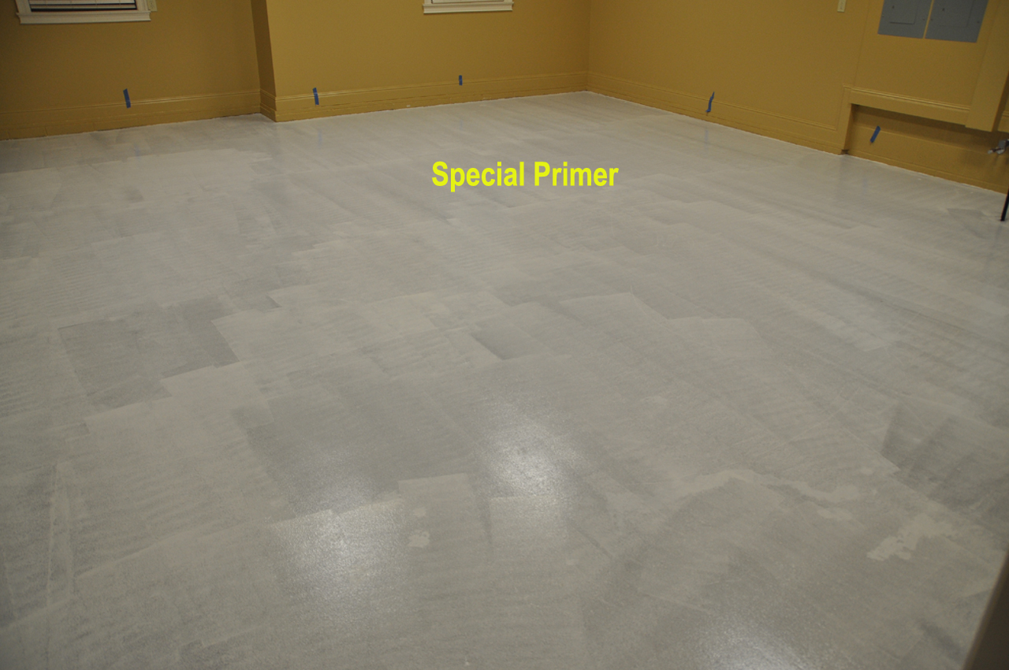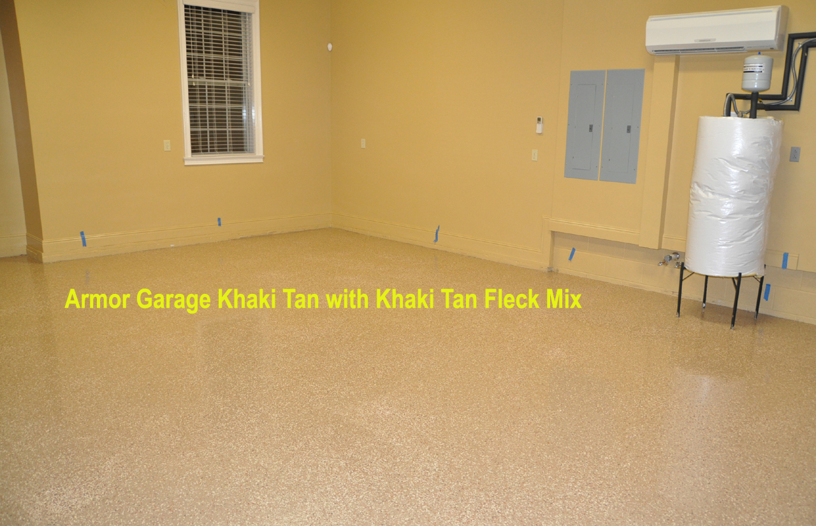

STEP BY STEP INSTUCTION:
1. Make sure existing epoxy is still properly adhered to concrete. You can do a pull test by cutting 1/4" squares in 12" x 12" area. Then cover with Gorilla Duct Tape and press firmly onto the epoxy. Then quickly tear up the tape and count how many 1/4" squares of coating came up, if less than 10% it means the epoxy is good to coat over, it more than that it means you should remove it entirely.
2. Sand the floor to rough up the existing coating with either a floor sander or buffing machine with a black pad.
3. Wet floor and then do an acid etch wash, be sure to rinse thoroughly to remove all the etching and sanding dust. Let the floor dry completely. You can squeegee the water off to help it dry faster.
4. Apply the Bonding Primer(Special Primer) over existing coating. Let dry overnight then apply our epoxy kit per the instructions. You now have a floor that will last you a long time.

